Delightful Danube and Prague
August 11, 2019

Day 1 Depart Detroit for Prague.

Day 2 Prague Arrive in Prague where we will be greeted by a Uniworld representative and transferred to our hotel.

Day 3 It is impossible not to be enchanted by Prague with its fabled skyline of spires, fortress-like castles, beautifully preserved architecture and the iconic Charles Bridge. It has been a magnet for artists, writers, scientists, and composers for generations. A thousand years of architecture, from ornate Gothic to fanciful postmodern, have been preserved in Prague. Famous for its dynamic energy and elegant ambiance, this city is fun as well as beautiful.

Featured excursions: Choice of Prague City Tour or Exclusive behind-the-scenes tour of Prague’s Estates Theatre and Municipal House.

Day 4 Prague, Transfer to Nuremberg (Embark)
Nuremberg will forever be associated with the post WWII Nuremberg trials, but the city’s profound historical significance stretches back many centuries before that. You will travel to Nuremberg by motor coach where your ship awaits. You will have a tour of Nuremberg with a local expert and have time for lunch on your own as well as time to explore historic Nuremberg before boarding the ship.

Featured tour: City tour with WWII Rally grounds visit.

Day 5 Cruising the Main-Danube Canal, Regensburg
The Main-Danube Canal is a masterwork of engineering that allows ships of all shapes and sizes to cruise from the Black Sea all the way to the North Sea. Sixteen locks punctuate the 106 miles stretch between Kelheim and Bamberg.

Featured excursions: 2,000 Years in One Hour Regensburg walking discover tour
or jewish Regensburg walking discovery tour or BMW factory visit. Note if BMW factory is closed, you will visit the Audi factury or museum.

Tonight, a special Captain’s Welcome Reception and Dinner will be prepared for you.

Day 6 Straubing, Cruising the Danube River, Passau
Today you will have a choice of two excursions:
Straubing walking discovery tour with brewery visit
Choice of Passau walking discovery tour with Old Town Walk or “Let’s go” Bavarian river bicycle ride

Day 7 Engelhartszell, cruising the Danube River
This may be the most leisurely day of your journey as you spend it onboard admiring the scenery. Today we leave Germany behind and sail into Austria, cruising through the Schlogener-Schinge, a hairpin loop in the Danube.

Day 8 Spitz or Melk, cruising the Wachau Valley
Your ship will dock in Spitz where you are faced with a difficult choice: Do you explore the riverbank village or visit one of the most beautiful libraries in the world? Later, you’ll want to find a comfortable seat as your ship cruises the Wachau Valley, an area of such unsurpassed beauty that UNESCO as declared it a World Heritage Landscape.
Choice of Excursions: Spitz village stroll with wine tasting or Melk Abbey with library visit.

Day 9 Vienna
The Grand Dame of the Danube, Vienna was the heart of the Austro-Hungarian Empire and remains to this day, the political and cultural center of Austria

Featured excursions:
Choice of City tour with Vienna State Opera or Exclusive City of Arts tour.

Day 10 Budapest
Located on opposite sides of the river, Buda and Pest each has a distinctive character and allure.
Vibrant Budapest, Hungary’s capital, offers an enchanting combination of East and West, old and new. Even its geography is made up of two parts: Buda (the hills) and Pest (the flatlands) divided by the Danube.

Featured excursions: Choice of Budapest City Tour or Do as the Locals Do walking tour.

Day 11 Budapest Today we say goodbye to the SS Beatrice and make are way to the airport for the journey home.

S. S. Beatrice
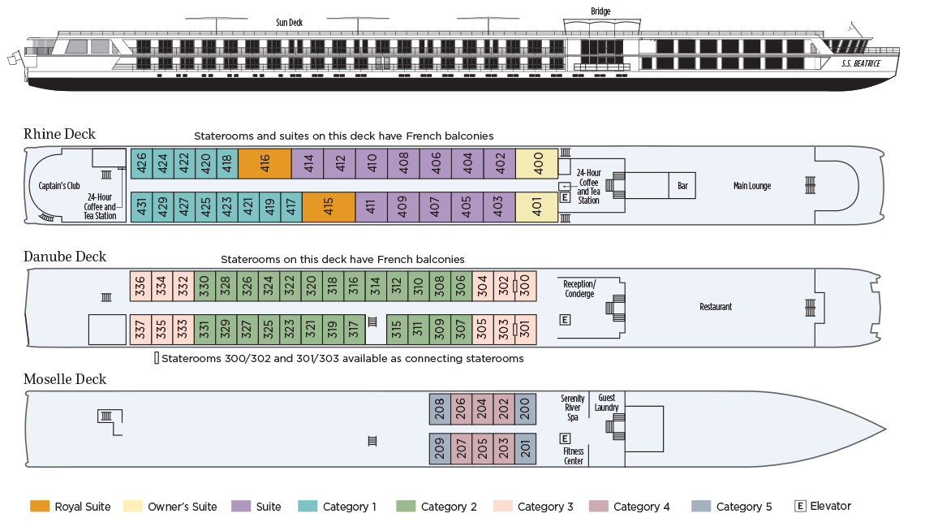

Please note that the Beatrice will be undergoing a major renovation in 2018 and will return as one of Uniworld’s super ships. The categories listed above will also change. I have attempted to match them as much as possible as the new ship’s deck plan is not yet available.

Pricing includes all meals aboard ship, all drinks (alcoholic and non alcoholic), gratuities, and transfers. Almost all of the excursions are also included. Once in a great while, Uniworld will offer an excursion that includes a cost.

